Amendment History:


TRADE BANK OF IRAQ
LIMITS
Functional Specification Document

Version | Date | Author / Changed By | Status | Change Description
1.0 | 05-Jan-2022 | Nauman Hussain | Initial

Table of Contents
1. Background 3
1.1 Introduction 4
1.2 Reference Documents 4
2. Functional Overview 4
3. Requirements 4
4. Existing Functionality 4
4.1 Existing Workflow 4
5. Workflow Description 5
5.1 LIMIT PARAMETER 5
5.2 LIMIT REFERENCE 7
5.3 LIMIT (DEAL PROCESSING) 8
5.3.1 Limit Products 8
5.3.2 Global Limits 9
5.3.3 Limit Products Hierarchy — Products and Sub-Products 10
5.3.3.1 Multi - Level Sub Products 10
5.3.3.2 Single Product Limits 10
5.3.4 Simple Customer Credit Limits 10
5.3.5 Limit Linked to One Account or Multiple Accounts 11
5.3.6 Limit to Multiple Accounts 13
5.3.7 Revolving / Non Revolving 13
5.3.7.1 Mix of Revolving and Non-Revolving Limits in a Limit Hierarchy 14
5.3.7.2 Secured Limits 15
5.3.7.2.1 Fixed Limit 15
5.3.7.2.2 Variable Limit 17
6. Reporting (Enquires and COB Reports) 19
7. Assumptions 19

Background
This Document has been prepared by NDC in response to requirement identified by TBI during Business Process Review (BPR), to develop certain functionality in T24. However, TBI doesn’t have a limit management structure in place in production. Therefore, due to this aspect NDC will be deploying a model bank structure in TBI.

Introduction
This document explains the understanding of T24 core limit module and explains the functional method for arriving at a solution.

Reference Documents
Reference Document | Description/Path | Author, Company
BPR and Gap Analysis

- Functional Overview
The LIMIT system controls credit risk against customers and markets. Customer limits are monitored in real-time during T24 on-line transaction processing. Other limits are monitored and reported on during the T24 overnight batch. Limits may also be reported as off-balance-sheet items in CRB reports.

Requirements
There is no gap identified during the BPR session. Therefore, core limit module of T24 will be delivered to TBI.

- Existing Functionality

Existing Workflow
Below is the key functionality the system provides for the creation of limits in the system.
- Limit Parameter
- Limit Reference
- Limit ( Deal Processing)

- Workflow Description

LIMIT PARAMETER
Within this file are defined parameters that determine the way in which the LIMIT system operates. Only one record with an ID of SYSTEM is required. In summary the LIMIT.PARAMETER controls the following:

- An indicator to specify whether Foreign Exchange contracts are, or are not, to be netted before LIMIT comparison.
- A 'number of days' to define how many days prior to LIMIT Expiry Date and Review Date the approach of these events is to be reported.
- A date and cycle to indicate when the first revaluation occurs and at what frequency thereafter.
- A date and cycle to indicate when a full Central Liability report (including those Liability number’s which did not move) needs to be produced in the back-end process.
- A date and cycle to indicate when the Commodity, Country and Currency reports must be produced.
- A number of days; administrative extension days, define the maximum number of days by which the expiry date of a LIMIT can be "administratively" extended before a new expiry date must be assigned to the LIMIT.
- The LIMIT product definition according to the specific requirements of the Bank. The most important feature of this file is that it allows the user, for each financial application, to define the precise rules applicable to an environment. In this way, the LIMIT verification process can be established by the user according to a user’s own set of rules without any program maintenance.
- Some other general definitions.
.
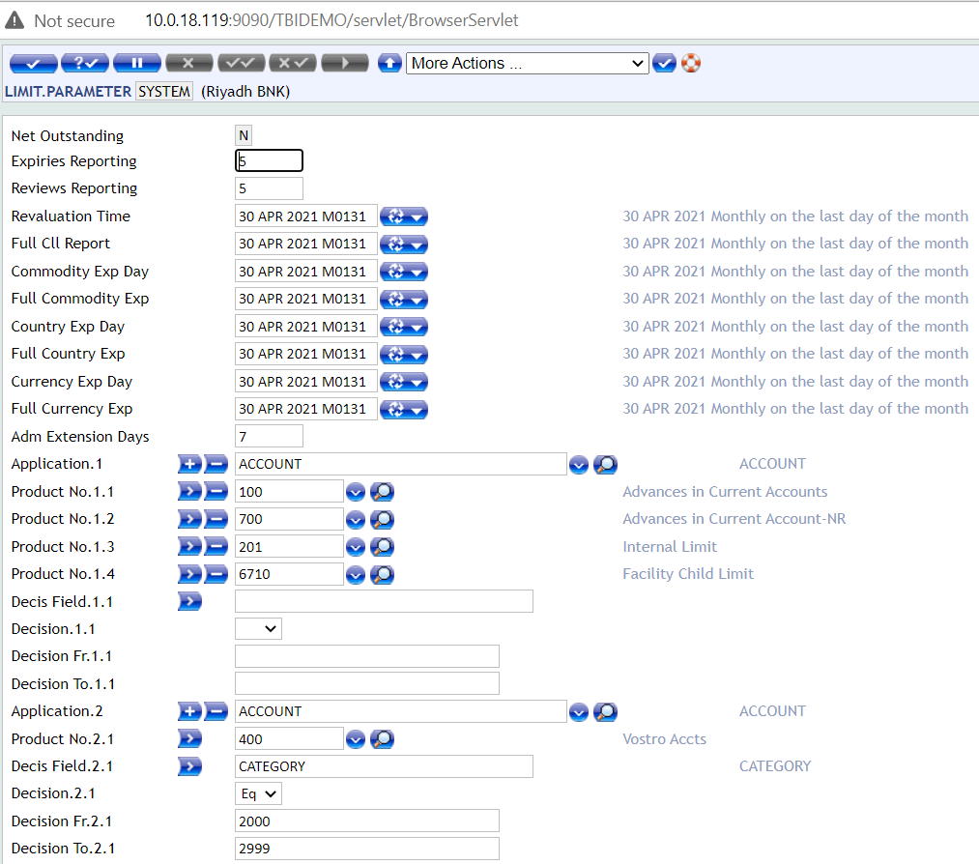

The product group definition that allows the user to specify the different products, which in his opinion, must be part of the Commodity, Country or Currency exposure.

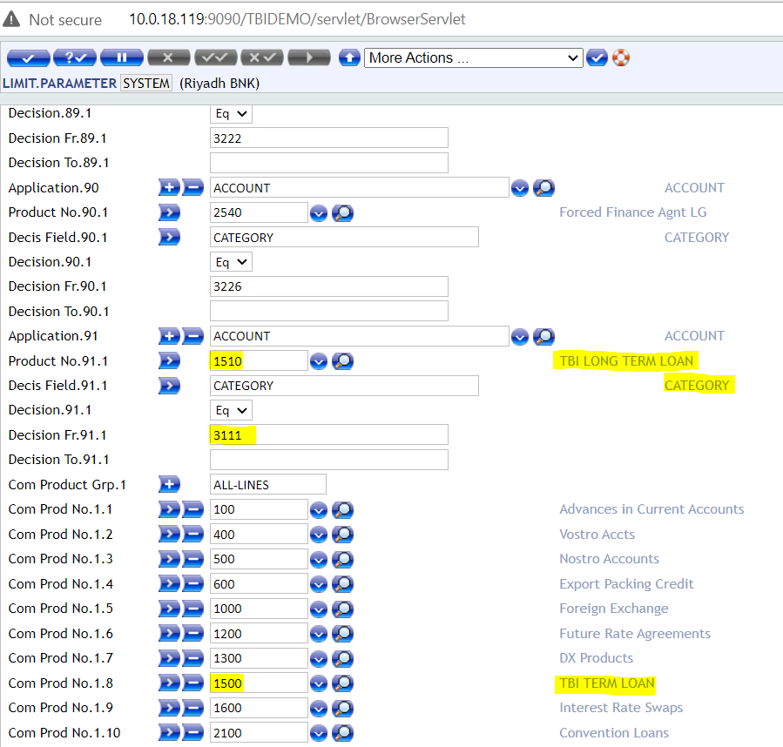

LIMIT REFERENCE
This table defines various parameters and links contracts and accounts to LIMIT.REFERENCE. The key to this table is the product, defining the product hierarchy which is the second dimension to Limits.

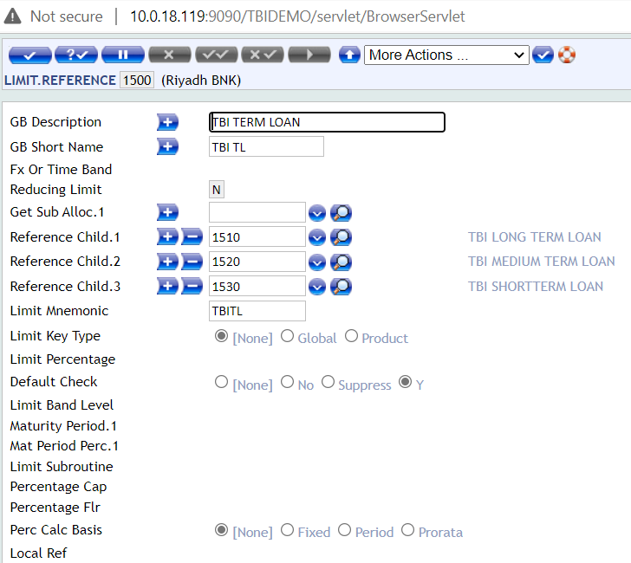

Each Limit type (known as LIMIT.REFERENCE within the system) can be defined as being part of a hierarchy, made up of a Global Limit, Product Limit and Sub-Product Limit.
Where Global Limits are required these must be defined in this table and the products which are to be included in global limits.
This table is also used for defining whether the LIMIT.REFERENCE is one that requires checking each time, or whether it is updated for information purposes only.
Two additional associated multi value fields MARGIN.LEVEL and MARGIN.EVENT are provided in LIMIT and LIMIT.REFERENCE applications.
Margin Level represents the percentage ratio between the Limit amount utilised by underlying transactions and the value of the collateral available for the Limit.
Potential values in the drop-down list associated with the field MARGIN.EVENT are defined by setting up the EB.LOOKUP table with records prefixed with ID LI.MARGIN.EVENT.

LIMIT (DEAL PROCESSING)

Limit Products
The second dimension to T24 limits is the product. A LIMIT product is an area of business for which the user wishes to set limits. LIMIT products are defined on the LIMIT.REFERENCE application and are linked to the underlying business using the LIMIT.PARAMETER application.
Defining Valid Limits Products using LIMIT.PARAMETER
The LIMIT products that are valid for a particular contract or account are defined on the LIMIT.PARAMETER application. As LIMIT products are fully user-defined (on LIMIT.REFERENCE), the mechanism for linking contracts and accounts to these products also needs to be fully user-defined. It is based upon any characteristic of the contract or ACCOUNT including, if required, local reference fields.
The parameter defines which LIMIT products are valid for a contract or account it defaults the LIMIT product, if no input is made.
For loans, two LIMIT products may be valid, a secured loan and an unsecured loan. The user has to distinguish between the two when the loan is input. If no distinction is made, then T24 applies a default of the first applicable product.
If the loan does not meet either of the above criteria then the LIMIT product corresponding to the "parent" product is used. T24 insists that there is always a default specification for each application being used. It can appear anywhere on LIMIT.PARAMETER. All other specifications for the application are checked in turn working down the LIMIT.PARAMETER record. When a match is found, the checking stops.

Global Limits
A higher level of LIMIT hierarchy may also be used if required. Should the user wish to restrict overall exposure to 250M USD equivalent, irrespective of the type of business, this can be achieved by making use of a global LIMIT.
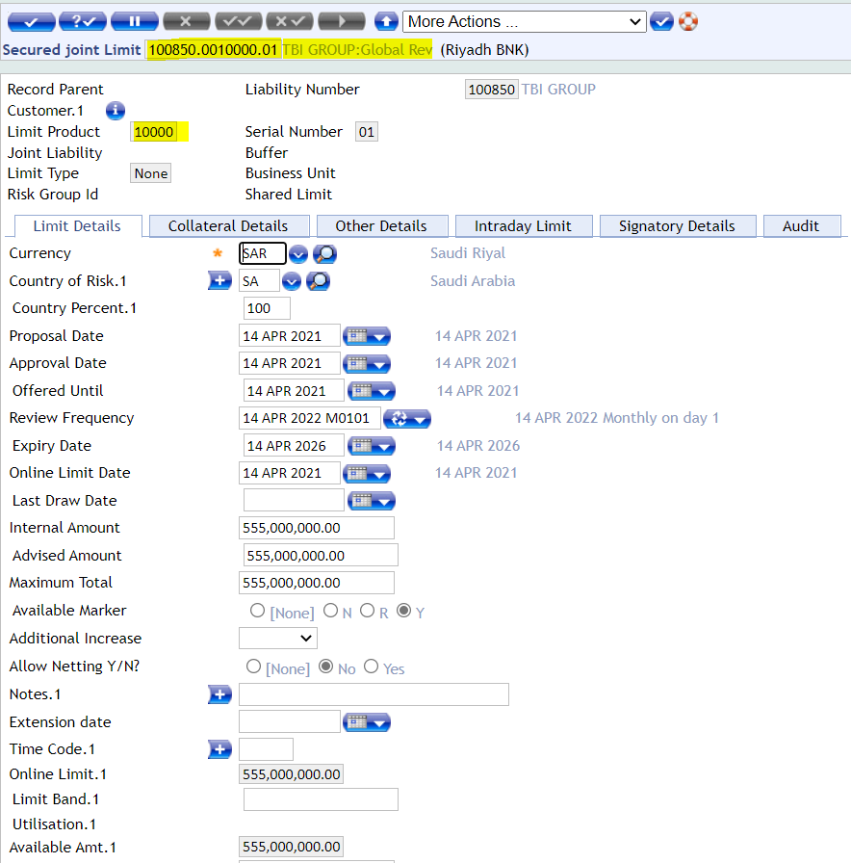

A Global LIMIT is enabled using the LIMIT.REFERENCE application. It has an id in the range 10000 to 9990000 (and therefore is above product and sub-product limits). An example of a global LIMIT for BNP is shown in the screen shot above.
In this example any foreign exchange or placement contracts with BNP would update the usual product and sub-product LIMIT records and would also update this global LIMIT.
Global limits can be restricted to only certain types of product. For example all treasury products could be included in the global LIMIT but corporate products could be excluded.

Limit Products Hierarchy — Products and Sub-Products
Some products may require a hierarchy of limits. For example you may wish to specify an overall LIMIT for Foreign exchange but within that a separate LIMIT for forward FX. This may be done within the LIMIT.REFERENCE application by specifying sub-products. The construction of the ID of the LIMIT.REFERENCE record shows whether it is a product or sub-product as follows:
Product - format 000nn00 e.g. 0001000
Sub Product - format 000nnnn e.g. 0001020

Limits can be maintained at any level in the structure and is updated automatically. If limits are being maintained at sub-product level it is not necessary to input limits at both levels.

Multi - Level Sub Products
A further nine levels of sub-product can be defined allowing the limit structure to be more complex. These sub-products are created by establishing a link between the lowest level sub-product and its parent, right through to the Product itself. The field SUB.PRODUCT.LEVEL in LIMIT.REFERENCE can be set to a value of 1 to 9 with 9 being the lowest level. The lowest level LIMIT.REFERENCE records must be entered first. The lowest level sub-product can then be added to LIMIT.PARAMETER with the decision criteria, which trigger that kind of deal.

Single Product Limits
Different LIMIT records can be specified for different banking products. For example LIMIT records may be specified for term loans and overdrafts. Different types of LIMIT products are defined using the application LIMIT.REFERENCE.
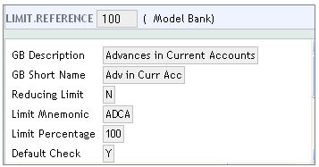
The following record shows a simple LIMIT.REFERENCE for Advances in Current Accounts. The record includes a description of the LIMIT product and a short mnemonic or use in error messages.

Simple Customer Credit Limits
A LIMIT may be recorded against any CUSTOMER using the LIMIT application. A simple LIMIT consists of three components: the id of the CUSTOMER to whom the credit line is available, the ‘product’ of the LIMIT which is the type of business products that can utilise this LIMIT and a serial number enabling more than one LIMIT of the same type to be maintained for a CUSTOMER.

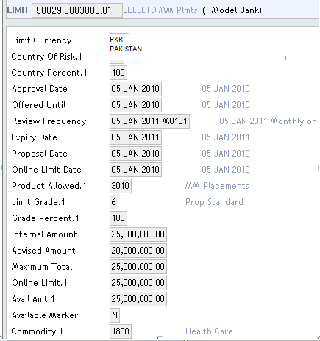
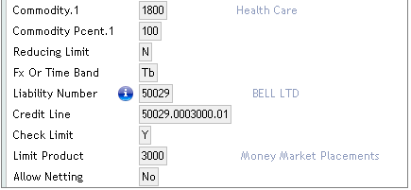

Limit Linked to One Account or Multiple Accounts
If the field SINGLE.LIMIT in ACCOUNT is set to “Y” then only one account can be attached to a limit record; if set to “N” then multiple accounts are allowed to utilize a single limit
The limit has been attached to the account in the field LIMIT.REFERENCE.

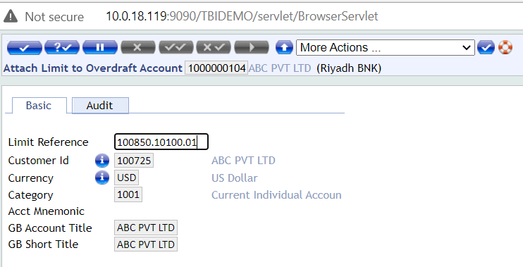

The same limit is now attached to another account; the system returns the following error:
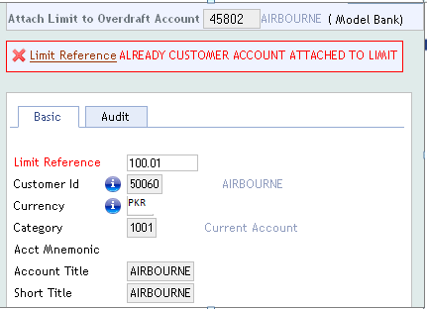

Limit to Multiple Accounts
If the field SINGLE.LIMIT in ACCOUNT is set to N or Blank, then multiple accounts can be linked to one limit. As in the example below, limit 100.01 has been linked to both AC 45737 and 45802.

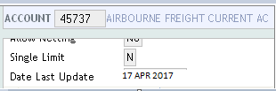

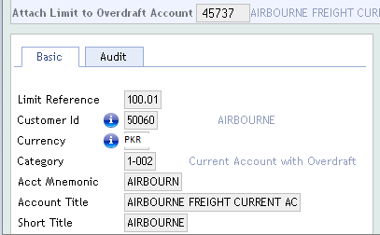
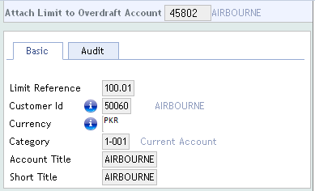

Revolving / Non Revolving
A limit maybe either Revolving (Non-Reducing) or Non-Revolving (Reducing).
If a limit is Revolving (Non-Reducing) then the available amount increases as deals mature or repayments are made. If a limit is Non-Revolving (Reducing), the limit is reduced to the extent of credit transaction affecting the debit balance in the account. This happens upon authorization of such a transaction. The reversal or repayment of such credit transaction does not restore the limit.
This specification is made on the LIMIT.REFERENCE application using the field REDUCING.LIMIT.
If set to 'Y', the limit is Non-Revolving (Reducing)
If set to 'N', the limit is Revolving (Non-Reducing)
The system default is 'N'
This means that the definition is made by product or sub-product and not by the individual LIMIT. The following are examples of both Revolving and Non-Revolving LIMIT.REFERENCE record.
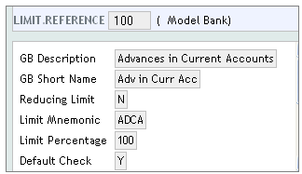
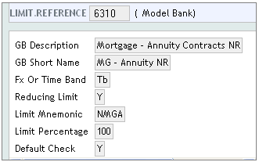

Mix of Revolving and Non-Revolving Limits in a Limit Hierarchy
Limits can have a mixture of Revolving and Non Revolving limits in the same hierarchy, but with a limitation.

A Non Revolving limit can be defined under a Revolving Parent Limit, but a Revolving Limit cannot be defined under a Non Revolving Limit.

To clarify further:
- If the Parent product is Revolving, then Child reference can either be Revolving or Non Revolving
- If the Parent product is Non revolving, then Child reference can only be Non revolving.
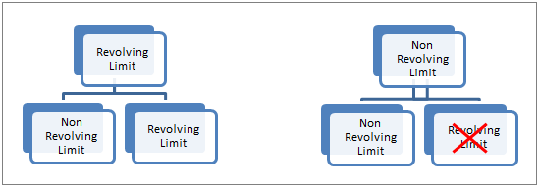

This will be allowed for all products including the Global Product Limit. When Reducing Limit is repaid, the repaid portion will be used by other products of the Limit structure, subject to the availability of overall limit. Allowing the Reducing Limit under a Non Reducing Parent will allow the facility to reuse the repaid portion.

Secured Limits

When COLLATERAL is linked to a LIMIT, the LIMIT becomes secured.

When a LIMIT is secured, the LIMIT must be defined as either fixed or variable in the FIXED.VARIABLE field on the LIMIT record.

- Fixed means that the LIMIT is unaffected by the value of the COLLATERAL and the link is being made for information only.
- Variable means that the available amount of the LIMIT will correspond to the current value of the COLLATERAL.

Fixed Limit

A fixed limit is secured once a piece of collateral has been allocated to it. The following example shows how to set up a secured limit.

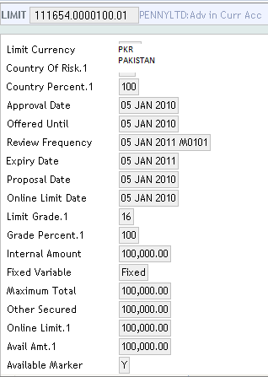

The customer Limit record must be in the system before a COLLATERAL.RIGHT record can be input with the LIMIT. In this example, the customer has been granted a limit of 100,000.

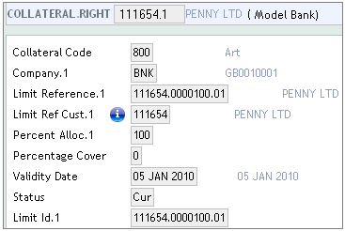

Once the LIMIT has been entered in the system, a COLLATERAL.RIGHT record should be entered for the customer. The LIMIT ID should be entered into the field LIMIT.REFERENCE in the COLLATERAL.RIGHT. This links the LIMIT to the collateral.

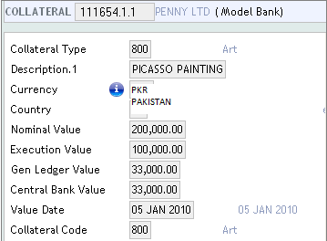

Enter the COLLATERAL record. In this case, a painting is being used as the collateral.
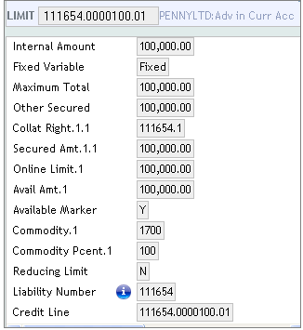

Once the collateral record has been authorized, the LIMIT record is updated with the collateral details.

Variable Limit
If, instead, the facility requires security, it must be indicated by the user whether the online LIMIT is to be system-maintained. This indicates a variable limit – which requires that the value of the collateral will be updated when the system goes online, in case of any changes in the market value or set to the full maximum total allowed and fixed at that level. The field ONLINE.UPDATE controls online update of fed (cash) type of collateral. If cash collateral such as AC, LD, MM, SC, FD, MD, LCE & LCI are attached to a limit record; any change in these collateral values are updated during the Close of Business process. If any collateral value is to be updated online, then this field is to be marked as "Y". On line update of collateral can be used only in variable type limits.

The current value of this security in this particular example is indicated by the system. In this example, there is a mortgage, currently valued at 85,000.00. In the Fixed limit the AVAIL.AMT is 100,000 however in the Variable limit the AVAIL.AMT is 85,000, which is linked to the underlying collateral. The screen shots below highlight the difference between using FIXED or VARIABLE. Notice the ONLINE.LIMT and AVAIL.AMT are different.

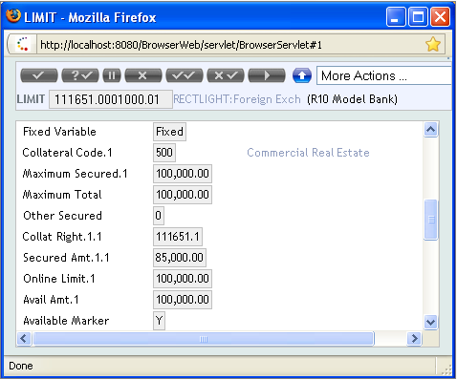

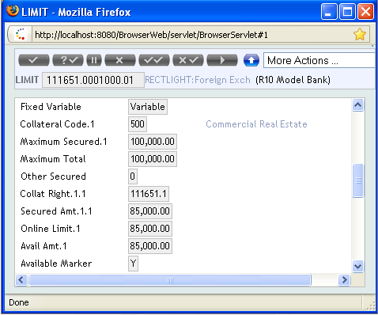

Reporting (Enquires and COB Reports)
Standard reports and Inquires pertaining to limit module will be provided made available. Apart from the provided reports/inquiries, will be handled through change management.

Assumptions
- Any integration / alignment of their existing system are neither covered, nor is part of our future development via this FSD.
- Since this is a Greenfield deployment, all the existing COB reports which are present in the system will be available. TBI has not requested any reports or enquiries therein.

